Active Directory Configuration - RH1
Schindler CRD Applications

Exported on 2025-08-19 05:04:54

Table of Contents

1 Prerequisites: 4
2 Procedure: 5
2.1 Configuration Apache 5
2.2 Create Windchill JNDI Adapters 6
2.3 Create Windchill Task Delegate Entries for JNDI Adapter 9
2.4 Update site.xconf to register the JNDI Adapters 10
3 AD Verification: 11

- Prerequisites:
- Procedure:
  - Configuration Apache
  - Create Windchill JNDI Adapters
  - Create Windchill Task Delegate Entries for JNDI Adapter
  - Update site.xconf to register the JNDI Adapters
- AD Verification:

Prerequisites:
- Need admin access on Windchill Application server.

Procedure:
- Shutdown Apache and Windchill.
- Make sure Windchill DS should be up & running.
- Take target LDAP backup.

Configuration Apache
- Copy the below entry from Source Windchill system under D:\ptc\Windchill_12.0\HTTPServer\conf\app-PDMLink-AuthProvider.xml
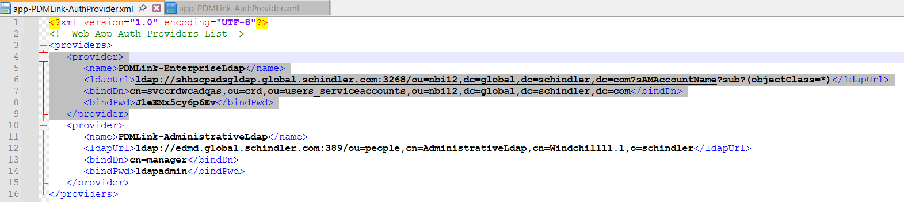

2. Paste it in the target Windchill system under D:\ptc\Windchill_13.0\HTTPServer\conf\app-PDMLink-AuthProvider.xml
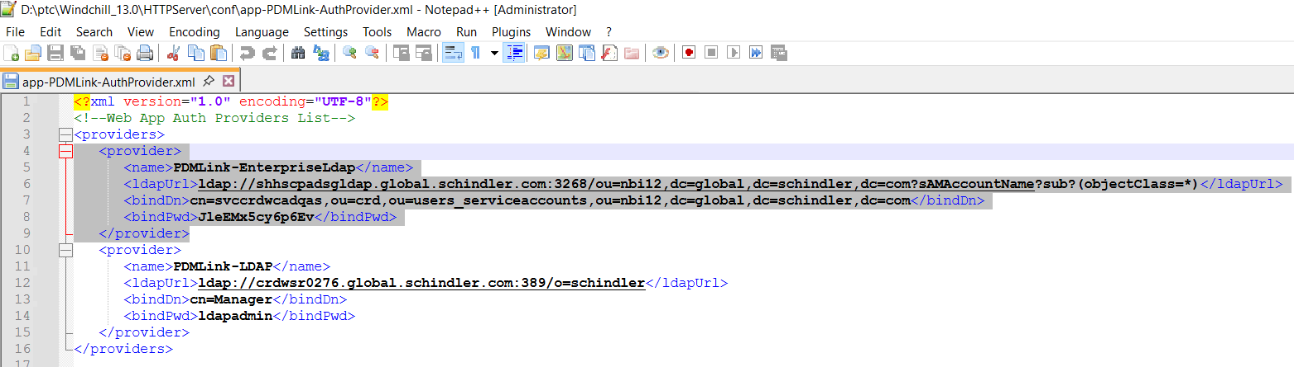

Note: Note that we are configuring this Windchill to the source Active directory, so we correspondingly give the ldapUrl, bindDN, bingPwd of the Source AD. For Production, we need to give the Production AD credentials.
3. Open Windchill Shell as an Administrator and navigate to HTTPServer directory and execute the below command.
ant -f webAppConfig.xml regenWebAppConf -DappName=PDMLink
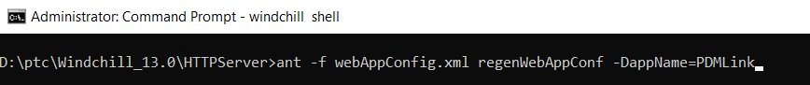

4. Make sure the build is successful.
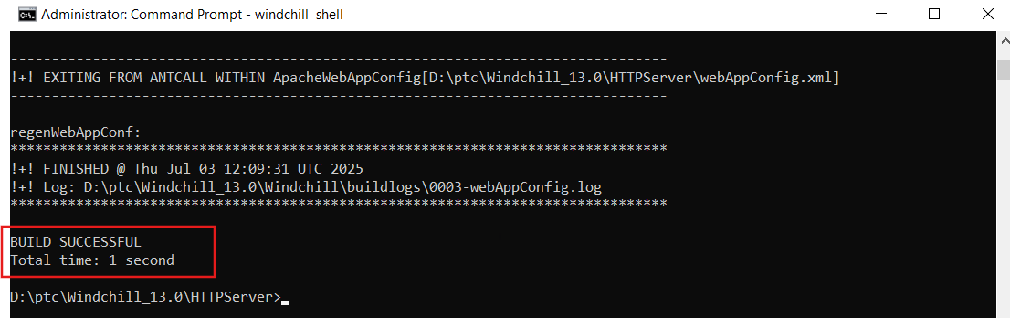

5. Make sure the value is propagated to the under the file: D:\ptc\Windchill_13.0\HTTPServer\conf\conf.d\30-app-PDMLink-Auth.conf
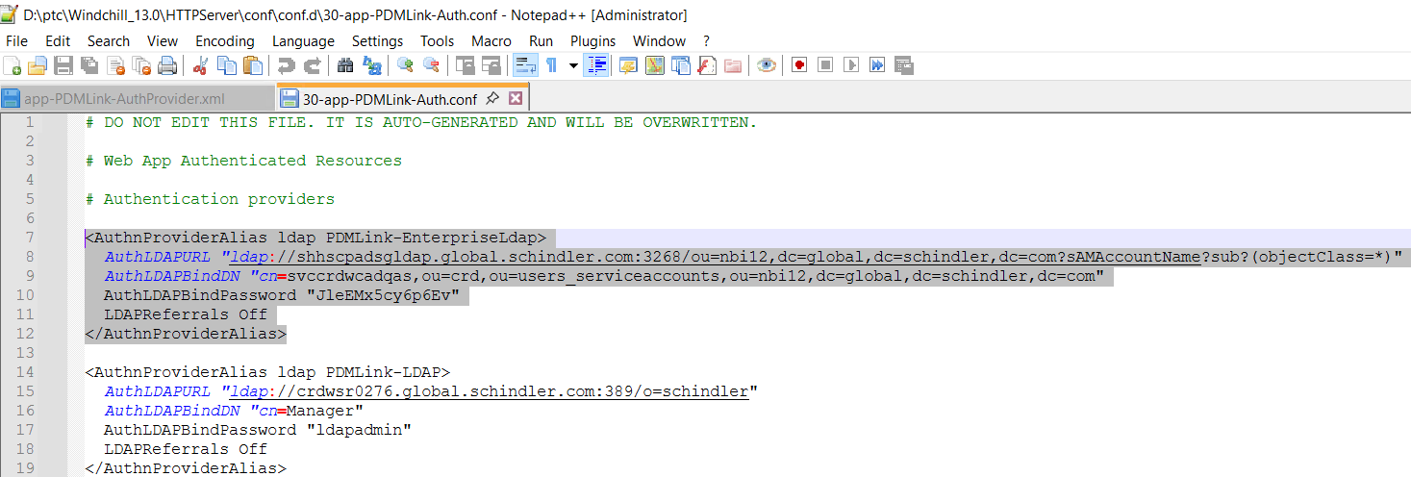

6. Start the HTTP Server and see that there are no errors.
7. Clean cache and start Windchill.

Create Windchill JNDI Adapters
1. Login to Windchill as admin and navigate to site → Utilities → Info*Engine Administration.
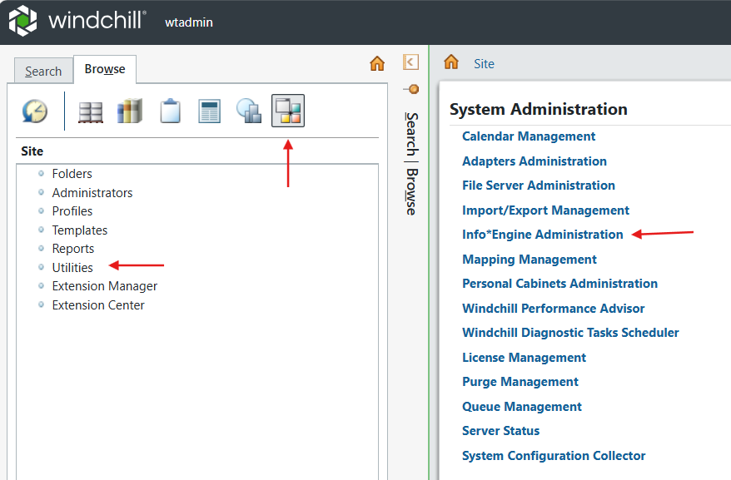

2. Create New JNDI Adapter.
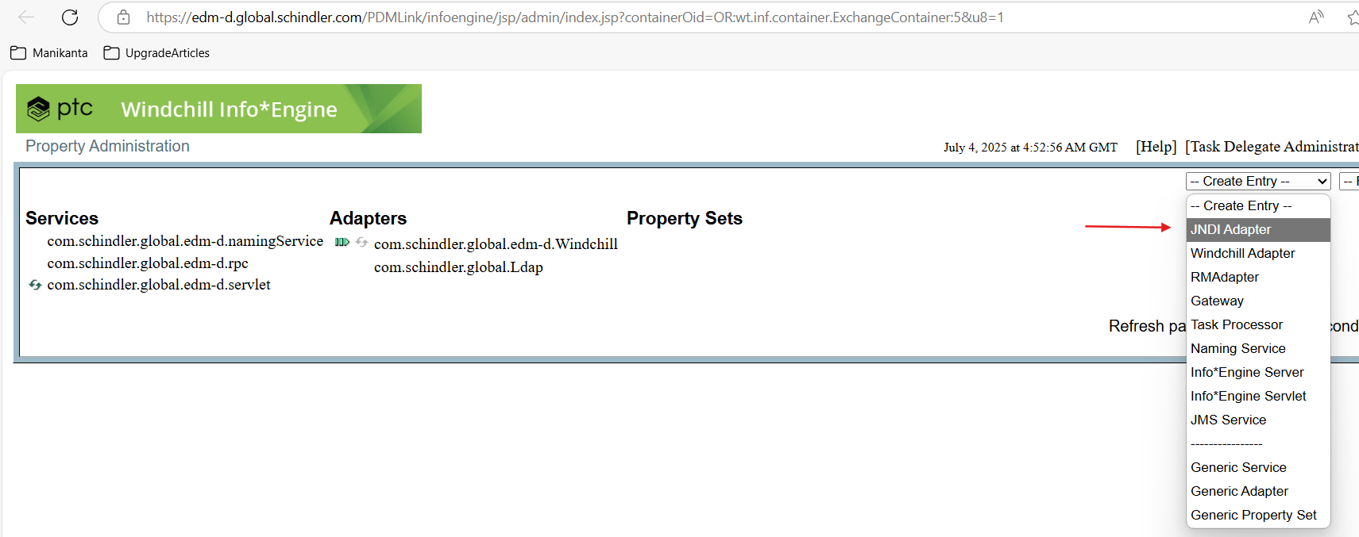
3. Provide the details as shown below and click on Create Adapter.
- Service Name: com.schindler.global.EnterpriseLdap
- Distinguished Name: Leave default value.
- Runtime Service Name: com.schindler.global.EnterpriseLdap
- Provider Url: ldap://shhscpadsgldap.global.schindler.com:3268
- Directory System Agent User: cn=svccrdwcadqas,ou=crd,ou=users_serviceaccounts,ou=nbi12,dc=global,dc=schindler,dc=com
- Directory System Agent Credentials: JleEMx5cy6p6Ev
- Search Base: ou=nbi12,dc=global,dc=schindler,dc=com
- LDAP Search Scope: SUBTREE
- LDAP Version: 3
Additional Properties:
- com.schindler.global.EnterpriseLdap .windchill.mapping.group.uniqueIdAttribute: sAMAccountName
- com.schindler.global.EnterpriseLdap.pageSize: 40000
- com.schindler.global.EnterpriseLdap.pagedSizeLimit: 500000
- com.schindler.global.EnterpriseLdap.windchill.config.directoryType: ADS
- com.schindler.global.EnterpriseLdap.windchill.config.doesNotContainGroups: false
- com.schindler.global.EnterpriseLdap.windchill.config.readOnly: true
- com.schindler.global.EnterpriseLdap.windchill.mapping.group.cn: displayName
- com.schindler.global.EnterpriseLdap.windchill.mapping.group.filter: (&(objectClass=group)(|(CN=CRD_RES_AP_WINDSCHILL_GLOBAL)(CN=CRD_USR_CRD-PAGE-OUTSIDE-CRD)(CN=CRD_USR_CRD-WORLDWIDE)(CN=INV_USR_INTERNAL)))
- com.schindler.global.EnterpriseLdap.windchill.mapping.group.objectClass: group
- com.schindler.global.EnterpriseLdap.windchill.mapping.group.uniqueMember: member
- com.schindler.global.EnterpriseLdap.windchill.mapping.user.cn: displayName
- com.schindler.global.EnterpriseLdap.windchill.mapping.user.filter: (sAMAccountType=805306368)
- com.schindler.global.EnterpriseLdap.windchill.mapping.user.member: memberOf
- com.schindler.global.EnterpriseLdap.windchill.mapping.user.objectClass: user
- com.schindler.global.EnterpriseLdap.windchill.mapping.user.uid: sAMAccountName
- com.schindler.global.EnterpriseLdap.windchill.mapping.user.uniqueIdAttribute: sAMAccountName
- com.schindler.global.EnterpriseLdap.windchill.mapping.usersOrganizationName: CRD
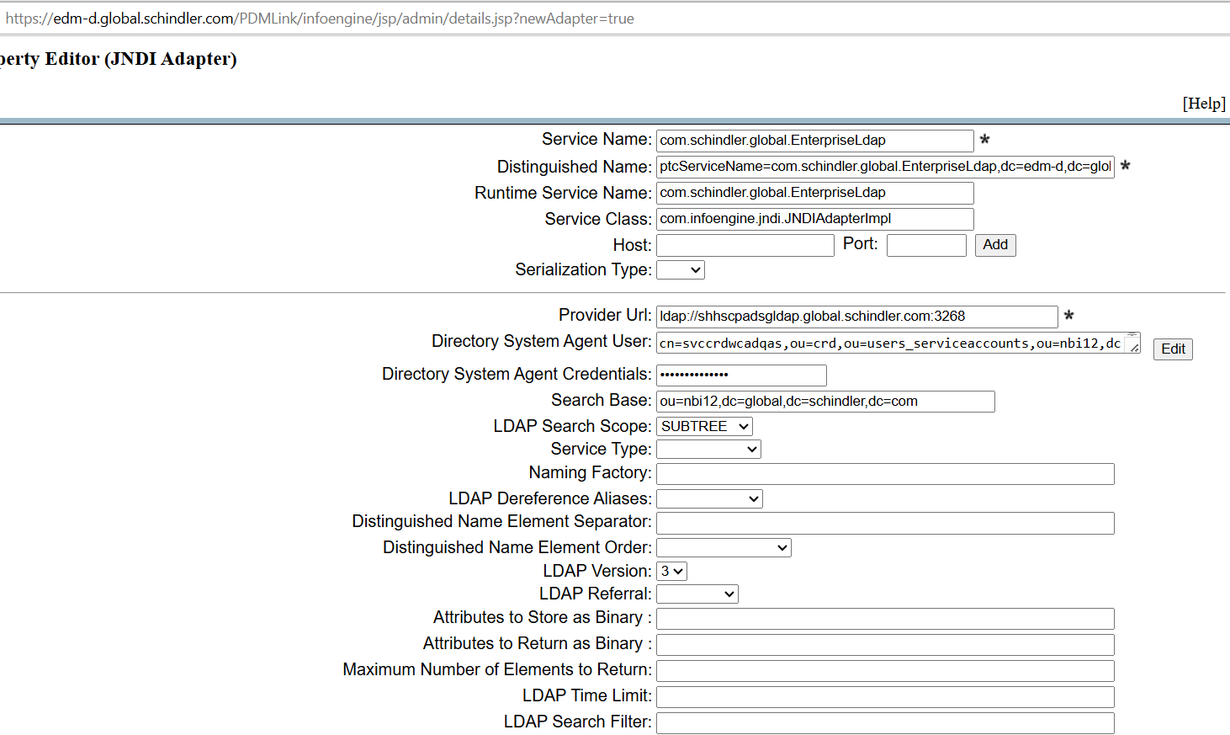
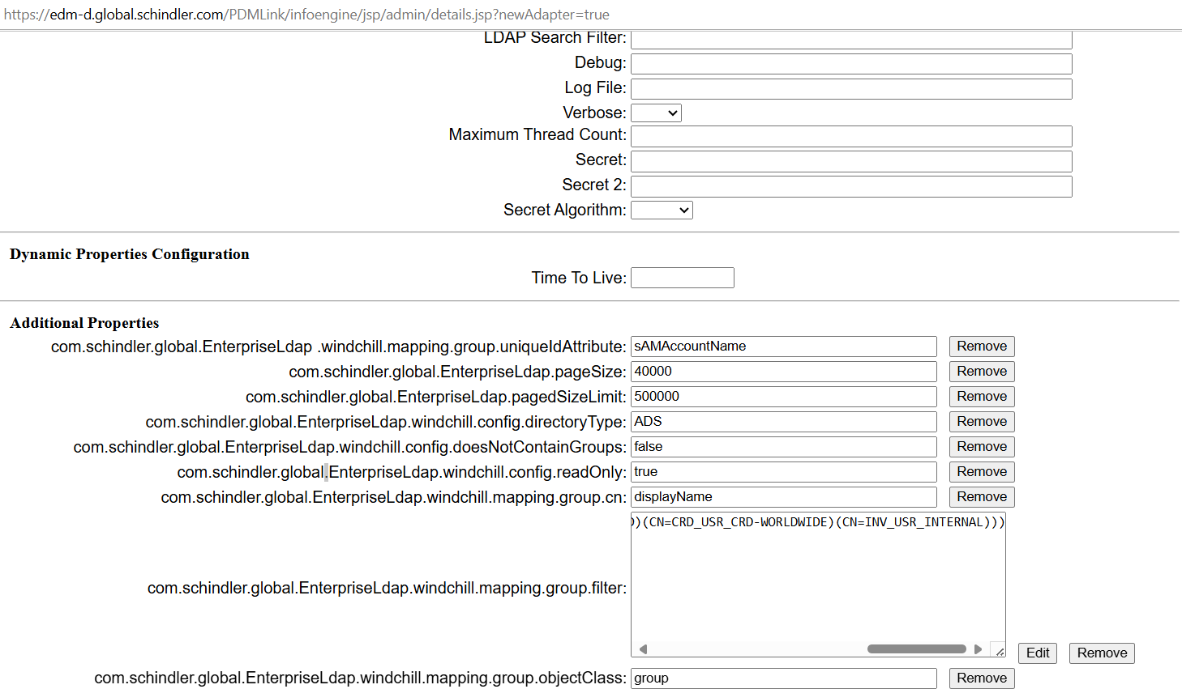
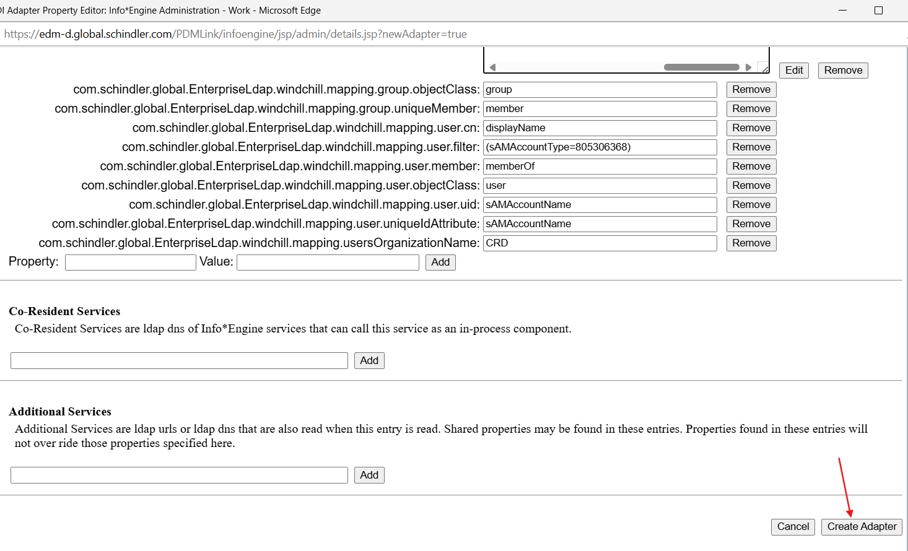

Create Windchill Task Delegate Entries for JNDI Adapter
- Click on Task Delegate Administration.
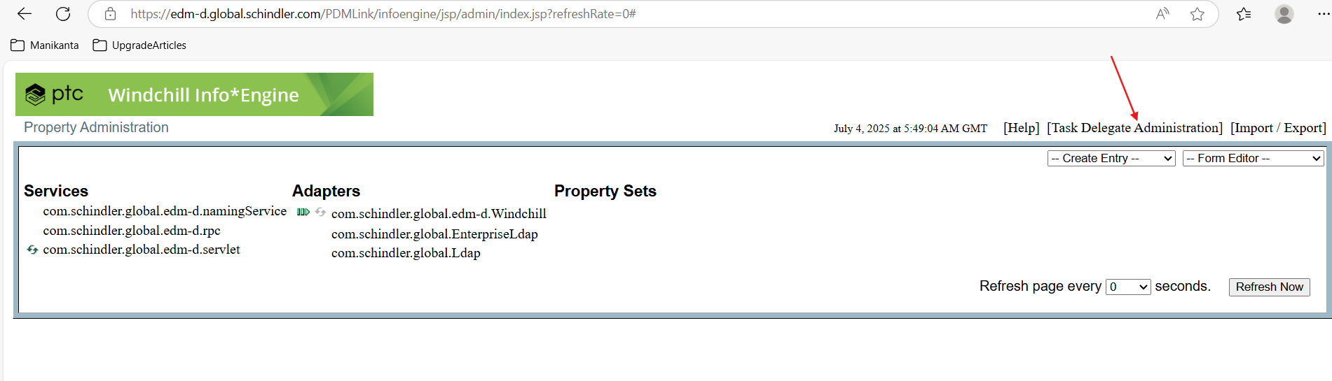

2. Click on Manage Repository.
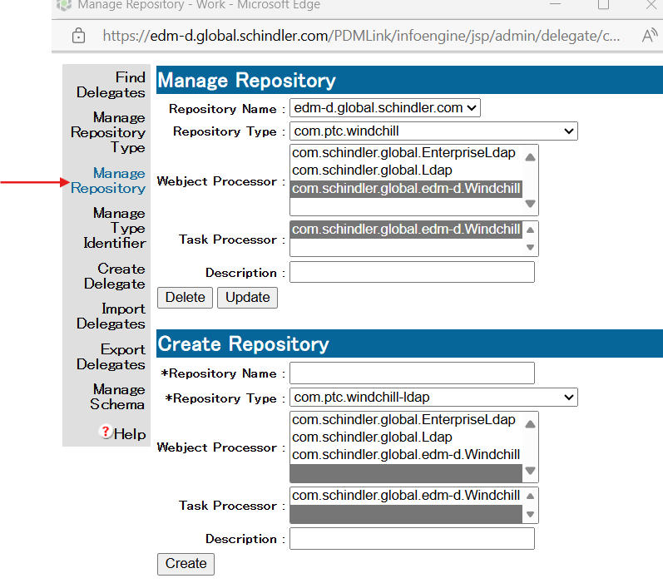

3. Create Repository with the below information.
- Repository Name: EnterpriseLdap.global.schindler.com
- Repository Type: com.ptc.windchill-ldap
- Webject Processor: com.schindler.global.edm-d.Windchill
- Task Processor: com.schindler.global.edm-d.Windchill
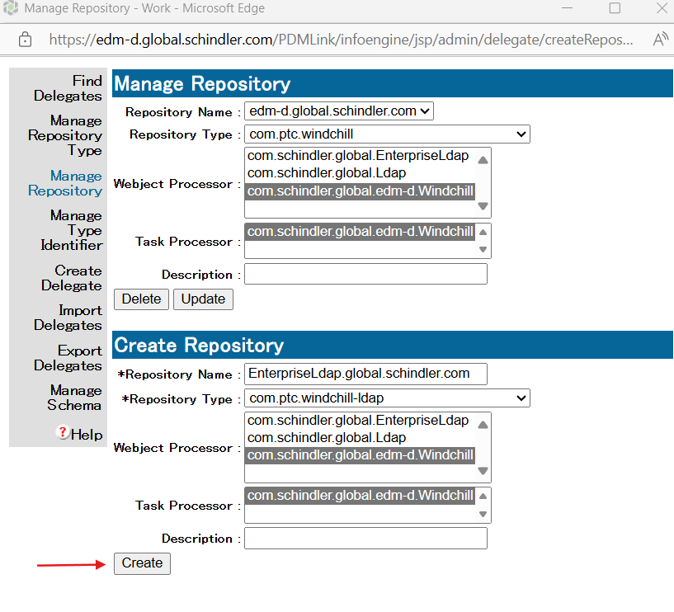

Update site.xconf to register the JNDI Adapters
- Take backup of site.xconf file.
- Add or update the following entry within the site.xconf to include JNDI Adapter.
<Property name="wt.federation.org.directoryServices" overridable="true"
targetFile="codebase/wt.properties"
value="$(wt.federation.org.defaultAdapter),com.schindler.global.EnterpriseLdap"/>

<Property name="mapcredentials.admin.adapters" overridable="true"
targetFile="codebase/WEB-INF/mapCredentials.txt"
value="com.schindler.global.Ldap^cn=Manager^ldapadmin"/>

<AddToProperty name="mapcredentials.admin.adapters"
value="com.schindler.global.EnterpriseLdap^cn=svccrdwcadqas,ou=crd,ou=users_serviceaccounts,ou=nbi12,dc=global,dc=schindler,dc=com^JleEMx5cy6p6Ev"/>
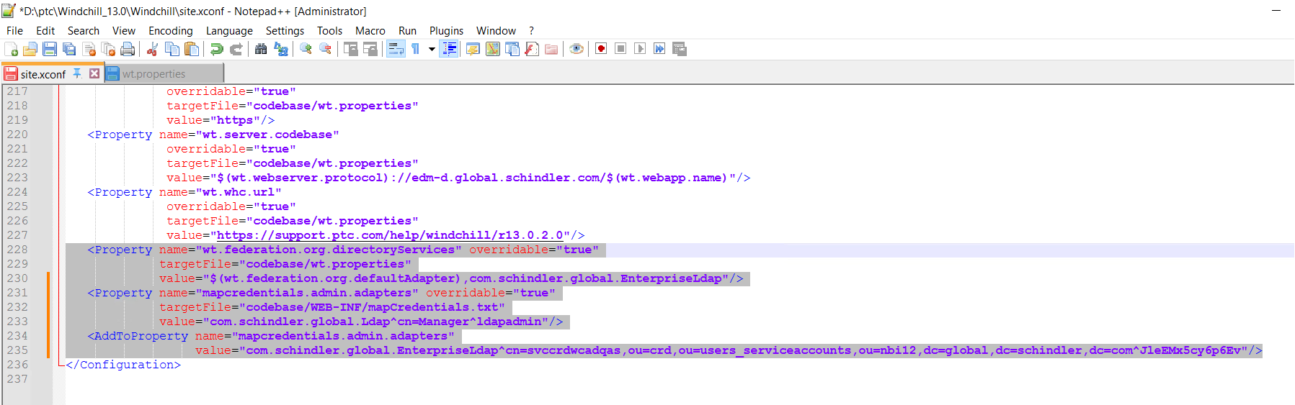

3. Launch Windchill Shell as an admin and execute xconfmanager -p to propagate the changes.
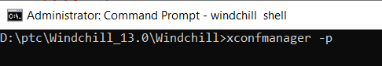

4. Make sure the command executed without issues.
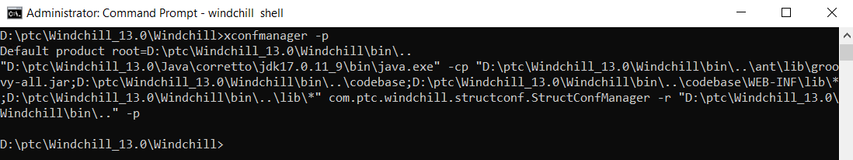

5. Stop Windchill, clean cache and start Windchill.

AD Verification:
- Login to Windchill as admin.
- Navigate to Site → Utilities → Participant Administration.
- Click on Add Participant and select the service as com.schindler.global.EnterpriseLdap.
- Try searching for any AD user as shown below.
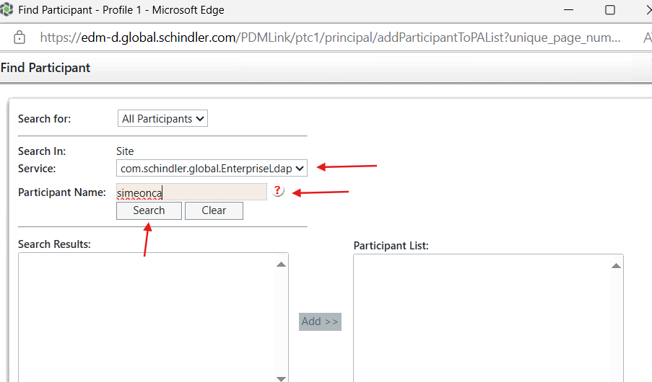

5. Was able to get the user details successfully.
